LAPORAN SOAL PERBAIKAN NILAI NO.5
DASPRO


NADYA AURORA GEBI AGISTA
NIM 244107020034
KELAS TI 1H

PROGRAM STUDI D-IV TEKNIK INFORMATIKA
JURUSAN TEKNOLOGI INFORMASI
POLITEKNIK NEGERI MALANG
2024
- Flowchart :
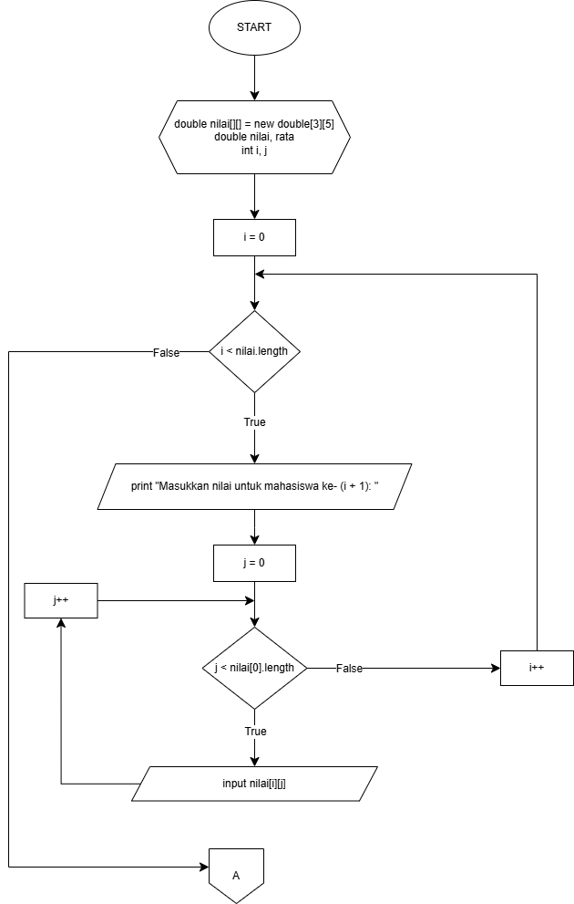

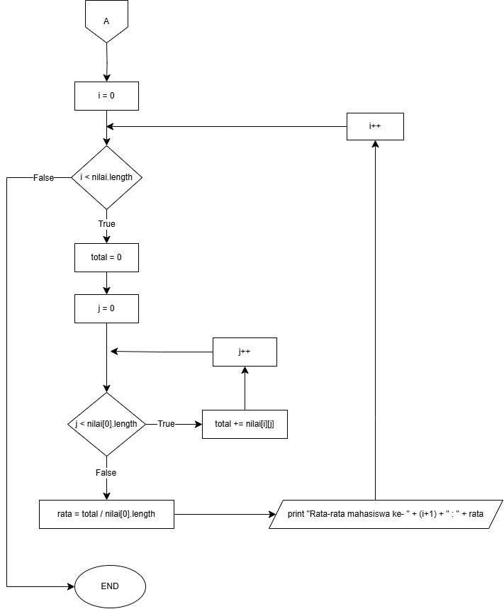

- Kode Program :
import java.util.Scanner;
public class nilai {
public static void main(String[] args) {
Scanner sc = new Scanner(System.in);

double nilai[][] = new double[3][5];

for (int i = 0; i < nilai.length; i++) {
System.out.println("Masukkan nilai untuk mahasiswa ke- " + (i + 1) + " :");
for (int j = 0; j < nilai[0].length; j++) {
System.out.print("Nilai ke- " + (j + 1) + " : ");
nilai[i][j] = sc.nextDouble();
}
}
for (int i = 0; i < nilai.length; i++) {
double total = 0;
for (int j = 0; j < nilai[0].length; j++) {
total += nilai[i][j];
}
double rata = total / nilai[0].length;
System.out.println("Rata-rata mahasiswa ke- " + (i + 1) + " : " + rata);
}
}
}

- Hasil Output :
